12.39: a) Refer to the derivation of Eq. (12.26) and Fig. (12.22). In this case, the red ring in Fig. (12.22) has mass M and the common distance s is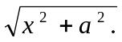Then, 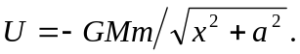 b) When x >> a, the term in the square root approaches 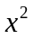
and 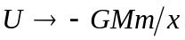, as expected.
c) 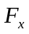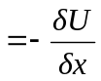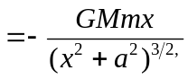,

with the minus sign indicating an attractive force. d) when x >> a, the term inside the parentheses in the above expression approaches and 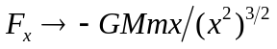 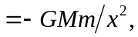 as expected. e) The result of part (a) indicates that 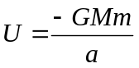 when 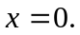 This makes sense because the mass at the center is a constant distance a from the mass in the ring. The result of part (c) indicates that 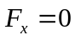when 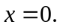 At the center of the ring, all mass elements that comprise the ring attract the particle toward the respective parts of the ring, and the net force is zero.

